Final Project Report

MadeInMyCountry.com



Project By
<<Ahmad Arshad>>

CERTIFICATE

This is to certify that Ahmad Arshad have worked on and completed their Software Project at Software & Research Projects Section, Department of Computer Sciences, Virtual University of Pakistan in partial fulfillment of the requirement for the degree of BS in Computer Sciences under my guidance and supervision.

In our opinion, it is satisfactory and up to the mark and therefore fulfills the requirements of BS in Computer Sciences.

Supervisor / Internal Examiner

<<Sir Asad-Ullaha>>
Supervisor,
Software Projects & Research Section,
Department of Computer Sciences
Virtual University of Pakistan

___________________
(Signature)

External Examiner/Subject Specialist
<<External Supervisor Name>>

___________________
(Signature)

Accepted By:

_____________
(For office use)

EXORDIUM

In the name of Allah, the Compassionate, the Merciful.

Praise be to Allah, Lord of Creation,
The Compassionate, the Merciful,
King of Judgment-day!

You alone we worship, and to You alone we pray for help,
Guide us to the straight path

The path of those who You have favored,

Not of those who have incurred Your wrath,
Nor of those who have gone astray.

DEDICATION

This project is dedicated to my future and my dedication to words making this world better as my project will be helpful not only for the rich countries but also for the poor as well.
ACKOWLEDGEMENT

This project consumed a lot of effort however I enjoy working and finishing this project as this is the first real time project for me. I also want to show my respect to all the free stuff that is available online the free courses and other open source project which gives me enough knowledge and exposure to the development.
PREFACE

This is my third project if I talk about the ideal list then it comes in 4th place however the I think it is more important and would be more beneficial for all of us .
Sometimes while making this project I feel like I may not make it to the finish line however I burnt my oil work hard believe in myself and now with the grace of Allah I have completed this project

Table of Contents
Chapter 1 8
Gathering and Analyzing info 8
Introduction 9
Project Purpose 9
Software Features 9
Operating Environment 9
Scope 9
Definitions, Acronyms and Abbreviations 10
Project Requirements: 11
User Requirements 11
Functional Requirements 11
Non Functional Requirements 13
Chapter 2 15
Designing the project 15

Chapter 1

Gathering and Analyzing info

Introduction

Project Purpose
The main purpose of To do list app is to remind the user about its daily task to preform actually nowadays we all are to busy in our work consequently the burden of work and anxiety due to this is increasing day by day and we all are very worried about our habit of forgetting things. So this is the only purpose of the To do list app

Software Features :
- program will start with the operating system
- program will have date and time of the task
- user can remove add complete and edit the task in the tasks panel
- the deleted task would remove from the user and the completed one will be marked as completed
- user can also reschedule his tasks
- user will be notified when the time or date of the task reached
- program will reside in the task bar

Operating Environment
It is a desktop application written in python an only runs in os which have python installed.

Scope
Features :
  - program will start with the operating system
  - program will have date and time of the task
  - user can remove add complete and edit the task in the tasks panel
  - the deleted task would remove from the user and the completed one will be marked as completed
  - user can also reschedule his tasks
  - user will be notified when the time or date of the task reached
program will reside in the task bar

Definitions, Acronyms and Abbreviations
Used Abbreviations and Acronyms:
- AD: Administrator
- FR: Functional Requirement
- US: Use Case

Project Requirements:

User Requirements
E-Drug stores will have three types of users first one is staff and the second is businessmen and the third one is customer .
- Can add remove delete modify or mark the tasks as completed
- Automatic running on startup
- can minimize the app
- apps must be running on taskbar

Functional Requirements
    - program will start with the operating system
    - program will have date and time of the task
    - user can remove add complete and edit the task in the tasks panel
    - the deleted task would remove from the user and the completed one will be marked as completed
    - user can also reschedule his tasks
    - user will be notified when the time or date of the task reached

Details of Functional Requirements
- Startup programs
Program will start at startup .
- Login/Logout:
User can login and logout using his credentials which was given to him/her by the administrator of the store after starting the application user will put his/her credentials otherwise he we not be able to perform or use the app he will only see a login screen and after putting only the right credentials he/she will be able to utilize software for both the businessmen and the customers the homepage is almost same with very few changes .
- Create posts
Both the businessmen and the customer can create post and it will be published however their would be medal of business men or the basic account for a customer on the post. Another difference is the posts priority on verified account. Moreover another medal is of the review my the company for quality assurance in the search result or the homepage of the recent posts.
- Editing or updating an existing post
Both the customer and the businessmen can update his/her post as it is the main right of every individual to to update or edit his post about the price change or name changes.
- Delete a post
The post owner have the right to delete his or her post however this would only be done within the time of 30 days to avoid any kind of fraud One more this is staff can also delete a post if he receive complaints about a user or a certain post or the post seems to be fraud.
- Set appointments
Businessmen and customer can set appointments with each other by request or by sharing location .
- Use the Madeinmycountry.com services as a middlemen
Businessmen and customer can use the Madeinmycountry.com service to close or made a deal for him or her to avoid fraud or save his or her time.
- Use Madeinmycountry.com service as a tester or quality assurance
Both the businessmen and the customer can use the Madeinmycountry.com service as a quality assurance businessmen use the service to assure his or her customer his quality and customer can use to clarify it only the product that we have in the store can be reviewed and only then the quality assurance team will assure the quality only the stock reside in the store have the quality assurance service.

- Report a User
Both the customer and the businessmen can report a user if he or she finds or feels like the other person in a fraud and trying to rob the other person.
- Apply for account verification
Both the businessmen and the customer can apply for account verification as it comes with a lot benefits like verification badge will be displayed on your profile
- Sell and buy business and their copyrights
Business can sell out his business by create a post in business section customers and other user of the app can buy business and talk to the businessmen directly
- Service of the Madeinmycountry.com
Except manufacturing there is almost every service that is provided buy the Madeinmycountry.com

Non Functional Requirements
- We will use the database for better reliability and security of the software.
- We have authorize the right to add medicine and add new users to admin only for better security options. In addition it have a benefit that admin is responsible for the stock, medicine prices, medicine position in the store and the stock information.
- We will use the light weight GUI Frame Work that will speed up the overall performance
- By searching a medicine user would be shown all the information of that medicines like its ingredients, formula formations and prices which would improve the user experience.
- There would be button of backup that user can use to back up the database file into other places of computer
- Software will store the location of the medicine in the store so that it would be easy for the sales men to find a certain medicine which will save much time.

Use Cases and Usage Scenarios

Use case diagram:
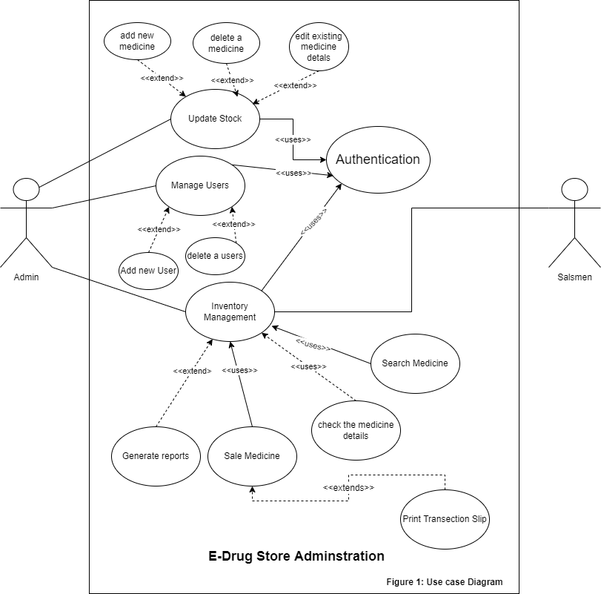

Usage scenarios:

Use Case Title | Authentication
Use Case ID | DS-AUTH-US_001
Requirement ID | DS-FR-0001
Actor | Admin. User
Description: This use case is for the authentication of the users (Login/Logout). When a user will open the application he/she will have to authenticate him/herself by putting the credentials assign to him/her.
Pre-Condition :
User have been registered before.
He/She have put the correct credentials.
Task Sequence |  | Exceptions
- User will open the application
- User put his or her credential in the login page and press the login button |  | System may show user authentication exceptions.
Post Conditions :
User will be promoted with his working environment as if he is logged in as admin or the normal User(Salesmen)
Un-Resolved Issues:
Authority :
Modification History : <1.0>
Author: E-Drug Store Administration

Use Case Title | Update Stock
Use Case ID | DS-UPMED-US_002
Requirement ID | DS-AD-FR-0002
Actor | Admin
Description: The use case is for the administrator to update stock
Pre-Condition :
User much be logged in as an Admin
Task Sequence |  | Exceptions
- User will open the application
- User put his or her admin credential in the login page |  | System may show user authentication exceptions.
- User will click on the Update Stock button
Post Conditions :
Admin will be given an interface to add stock where there are different options like add, edit delete or remove a medicine.

Uses | Authentication
Extends
Un-Resolved Issues:
Authority : Administrator
Modification History : <1.0>
Author: E-Drug Store Administration

Use Case Title | ADD A NEW MEDICINE
Use Case ID | DS-ADDMED-US_003
Requirement ID | DS-AD-FR-0003
Actor | Admin
Description: The use case is for the administrator to add new medicines to the stock
Pre-Condition :
User much be logged in as an Admin
User have clicked on update stock
Task Sequence |  | Exceptions
- User will open the application
- User put his or her admin credential in the login page |  | System may show user authentication exceptions.
- User will click on the Update Stock button
- User will click on the add new medicine button  - User will enter the medicine name and its attributes to the add medicine form and click on the add medicine button. |  | May be User will promoted with the exceptions below according to its input  - Already have the same medicine name.  - Invalid medicine name  - Medicine name can’t be empty  - Medicine quantity , Sale price or purchase price can’t be less than 1  - Medicine quantity, Sale price or purchase price can’t be a negative value.
Post Conditions :
After filling the medicine form correctly system will give a popup message medicine added successfully
User will be return to the add new medicine form
Uses
Extends | UPDATE STOCK
Un-Resolved Issues:
Authority : Administrator
Modification History : <1.0>
Author: E-Drug Store Administration

Use Case Title |  | EDIT EXISTING MEDICINE DETAILS
Use Case ID |  | DS-UPDMED-US_004
Requirement ID |  | DS-AD-FR-0004
Actor |  | Admin
Description: The use case is for the administrator to the edit an existing medicines details
Pre-Condition :
User much be logged in as an Admin
User have clicked on edit an existing medicine details
Task Sequence |  |  | Exceptions
- User will open the application
- User put his or her admin credential in the login page |  |  | System may show user authentication exceptions.
- User will click on the Update stock button
- User will click on the update existing medicine button  - User will enter the medicine name and its new attributes to the Update medicine form and click on the edit medicine button. |  |  | May be User will promoted with the exceptions below according to its input  - Can’t find the medicine name  - Invalid medicine name  - Medicine name can’t be empty  - Medicine quantity , Sale price or purchase price can’t be less than 1  - Medicine quantity, Sale price or purchase price can’t be a negative value.
Post Conditions :
After filling the Update medicine form correctly system will give a popup message medicine Updated successfully
User will be return to the update medicine form
Uses
Extends | Update Stock
Un-Resolved Issues:
Authority : Administrator
Modification History : <1.0>
Author: E-Drug Store Administration

Use Case Title |  | DELETE A MEDICINE
Use Case ID |  | DS-DELMED-US_005
Requirement ID |  | DS-AD-FR-0005
Actor |  | Admin
Description: The use case is for the administrator to the delete a medicines details
Pre-Condition :
User much be logged in as an Admin
User have clicked on delete medicine details
Task Sequence |  |  | Exceptions
- User will open the application
- User put his or her admin credential in the login page |  |  | System may show user authentication exceptions.
- User will click on the update stock button
- User will click on the delete a medicine button  - User will choose to delete a medicine by name or id, after selecting the desired option user will enter the name or id according to its choice and then click on the delete medicine button. |  |  | May be User will promoted with the exceptions below according to its input  - Can’t find the medicine name  - Medicine name can’t be empty  - Can’t find the medicine id  - Medicine id can’t be empty  - Invalid medicine name  - Invalid medicine id
Post Conditions :
After entering the correct name or id and pressing enter. User will be given a popup message entry deleted successfully
User will be return to the delete medicine form
Uses
Extends | Update Stock
Un-Resolved Issues:
Authority : Administrator
Modification History : <1.0>
Author: E-Drug Store Administration

Use Case Title | Manage Users
Use Case ID | DS-UPMED-US_006
Requirement ID | DS-AD-FR-0006
Actor | Admin
Description: The use case is for the administrator to manage users
Pre-Condition :
User much be logged in as an Admin
Task Sequence |  | Exceptions
- User will open the application
- User put his or her admin credential in the login page |  | System may show user authentication exceptions.
- User will click on the Manage Users button
Post Conditions :
Admin will be given an interface to add stock where there are different options like add, edit delete or remove a medicine.

Uses | Authentication
Extends
Un-Resolved Issues:
Authority : Administrator
Modification History : <1.0>
Author: E-Drug Store Administration

Use Case Title | ADD A NEW USER
Use Case ID | DS-ADDUSER-US_007
Requirement ID | DS-AD-FR-0007
Actor | Admin
Description: The use case is for the administrator to add a new user
Pre-Condition :
User much be logged in as an Admin
User have clicked on Manage Users Button
Task Sequence |  | Exceptions
- User will open the application
- User put his or her admin credential in the login page |  | System may show user authentication exceptions.
- User will click on the manage user buttons
- User will click on the add new user button
- User will choose to create an admin account or a sales men account  - Enter his name and press create |  | May be User will promoted with the exceptions below according to its input  - User already exist  - User name can’t be empty  - Invalid user name
Post Conditions :
After filling the new user form. User will be given a popup message created user successfully.
User will be return to the create user form
Uses
Extends | Manage Users
Un-Resolved Issues:
Authority : Administrator
Modification History : <1.0>
Author: E-Drug Store Administration

Use Case Title | DELETE A USER
Use Case ID | DS-DELUSER-US_008
Requirement ID | DS-AD-FR-0008
Actor | Admin
Description: The use case is for the administrator to delete a user
Pre-Condition :
User much be logged in as an Admin
User have clicked on Manage Users
Task Sequence |  | Exceptions
- User will open the application
- User put his or her admin credential in the login page  - User have clicked on the Manage Users button |  | System may show user authentication exceptions.
- User will click on the delete user button
- User will enter his name and press delete user. |  | May be User will promoted with the exceptions below according to its input  - User doesn’t exist  - User name can’t be empty  - Invalid user name
Post Conditions :
After filling the deleting user form. User will be given a popup message deleted user successfully.
User will be return to the delete user form
Uses
Extends | Manage Users
Un-Resolved Issues:
Authority : Administrator
Modification History : <1.0>
Author: E-Drug Store Administration

Use Case Title | Inventory Management
Use Case ID | DS-INVEN-US_009
Requirement ID | DS-AD-FR-0009
Actor | Admin
Description: The use case is for the administrator to manage inventory.
Pre-Condition :
User much be logged in as an Admin
Task Sequence |  |  | Exceptions
- User will open the application
- User put his or her admin credential in the login page |  |  | System may show user authentication exceptions.
- User will click on the Inventory management button
Post Conditions :
User will be given the inventory management menu
Uses |  | Authentication
Extends
Un-Resolved Issues:
Authority : Administrator
Modification History : <1.0>
Author: E-Drug Store Administration

Use Case Title | Generate Reports
Use Case ID | DS-INVEN-US_010
Requirement ID | DS-AD-FR-0010
Actor | Admin
Description: The use case is for the administrator to generate report about inventory
Pre-Condition :
User much be logged in as an Admin
User have clicked on Inventory management
Task Sequence |  |  | Exceptions
- User will open the application
- User put his or her admin credential in the login page |  |  | System may show user authentication exceptions.
- User will click on the Inventory management button
- User will be given with choices buttons like generate profit loss reports or generate stock valuation and quantity.
- User will again asked about the duration like daily, weekly, monthly or custom date |  |  | May be User will promoted with the exceptions below according to its input in custom date  - Invalid Date
Post Conditions :
After getting the reports user will be given a message of printing the report or saving in computer.
User will be return to the inventory management.
Uses
Extends |  | Inventory management
Un-Resolved Issues:
Authority : Administrator
Modification History : <1.0>
Author: E-Drug Store Administration

Use Case Title | SEARCH MEDICINE
Use Case ID | DS-SEMED-US_011
Requirement ID | DS-USER-FR-0001
Actor | User
Description: The use case is for the salesmen to search a medicine
Pre-Condition :
User much be logged in as an normal user
Task Sequence |  | Exceptions
- User will open the application
- User put his or her salesmen credential in the login page |  | System may show user authentication exceptions.
- User will enter the medicine name id or its base formula and press Search |  | May be User will promoted with the exceptions below according to its input  - Can’t find the medicine name  - Medicine name can’t be empty  - Can’t find the medicine id  - Medicine id can’t be empty  - Invalid medicine name  - Invalid medicine id
Post Conditions :
After pressing enter user will get the details of medicines

Uses | Authentication
Extends
Un-Resolved Issues:
Authority : User
Modification History : <1.0>
Author: E-Drug Store Administration

Use Case Title | SELL MEDICINE
Use Case ID | DS-SELMED-US_012
Requirement ID | DS-USER-FR-0002
Actor | User
Description: The use case is for the salesmen to get details of a medicine
Pre-Condition :
User much be logged in as an normal user
Task Sequence |  | Exceptions
- User will open the application
- User put his or her salesmen credential in the login page |  | System may show user authentication exceptions.
- User will click on the search medicine button  - User will enter the medicine name id or its base formula and press Search |  | May be User will promoted with the exceptions below according to its input  - Can’t find the medicine name  - Medicine name can’t be empty  - Can’t find the medicine id  - Medicine id can’t be empty  - Invalid medicine name  - Invalid medicine id
- User will select the medicine enter the quantity and press print |  | Maybe user will promoted with the exceptions below according to its inputs  - Sell quantity can’t be greater than the stock quantity.  - Invalid quantity  - Printer not connected or not found
Post Conditions :
After pressing getting print user will again redirected to the search medicine GUI

Un-Resolved Issues:
Uses | Search Medicine
Extends
Authority : User
Modification History : <1.0>
Author: E-Drug Store Administration

Development methodology

Chosen Methodology
Software development methodologies are also known as system development methodologies. Actually this is system development life cycle, or it can be called System Development Process. Software development methodologies are frames that are used to structure, control and plan the process of developing system.

For this project I find vu process model best as it has several advantages
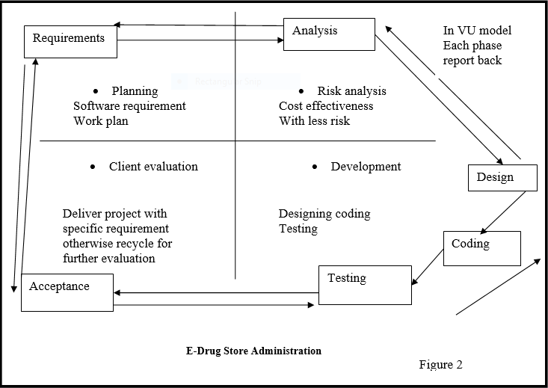
VU Process Model
The above is VU process model which is combination of waterfall and spiral models. It has five phases first one is learning and analyzing requirements secondly making of SRS third Test phase 1 fourthly Test Phase 2 and at the end Final deliverable .In the requirement phase system goals services and constraints are established after discussion with users.

Reason for Chosen Methodology
The main knowledge behind this model is that to get the benefits of both these models. Basically, Water Fall Model is a framework for software development in which development proceeds chronologically through a sequence of phases, starting with system requirements analysis and leading up to product release and preservation, whereas the key characteristics of spiral model is risk management at regular points in the whole software development cycle. In VU Process Model we will be working in phases to complete our given project.

- This is sequenced model
- This model is easy to understand and use
- Each phase has specific deliverable
- In this model phases are completed and processed one at a time.
- Avoidance of risk is enhanced.
- Additional functionality can be added later.
- This model is used when cost and risk evaluation is important.
- This methodology is also used when users are unsure of their requirement.
It is also used when significant changes are expected.

Work Plan Gantt chart

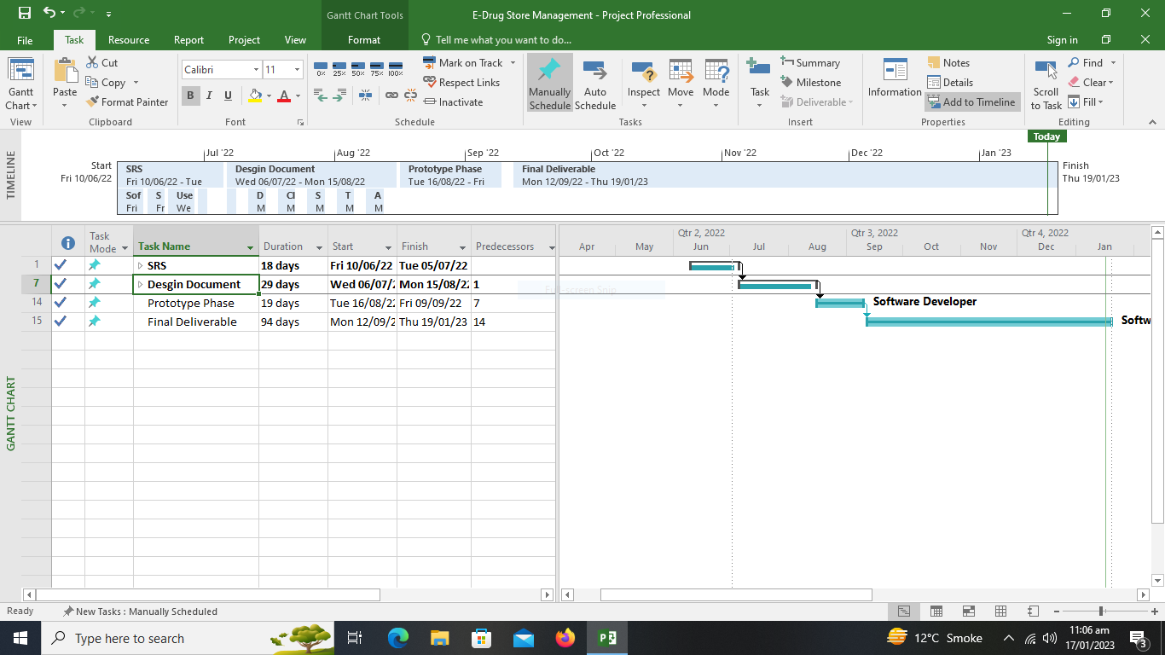
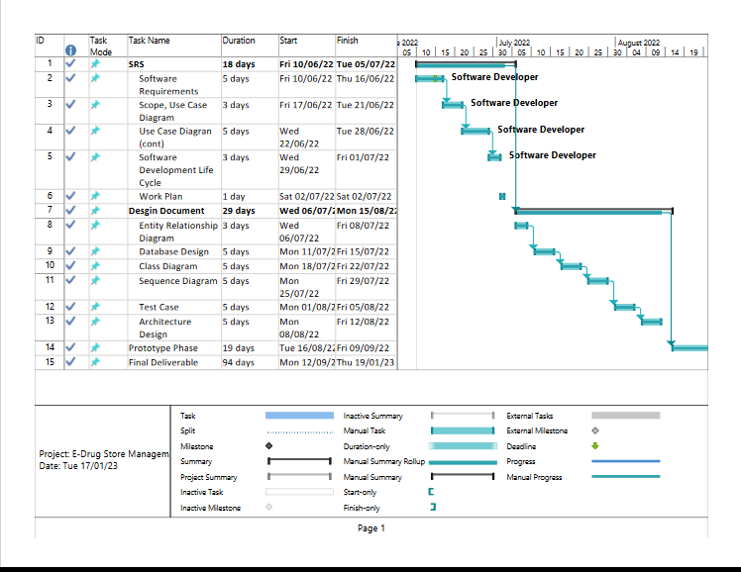

Project Schedule (Submission Calendar)
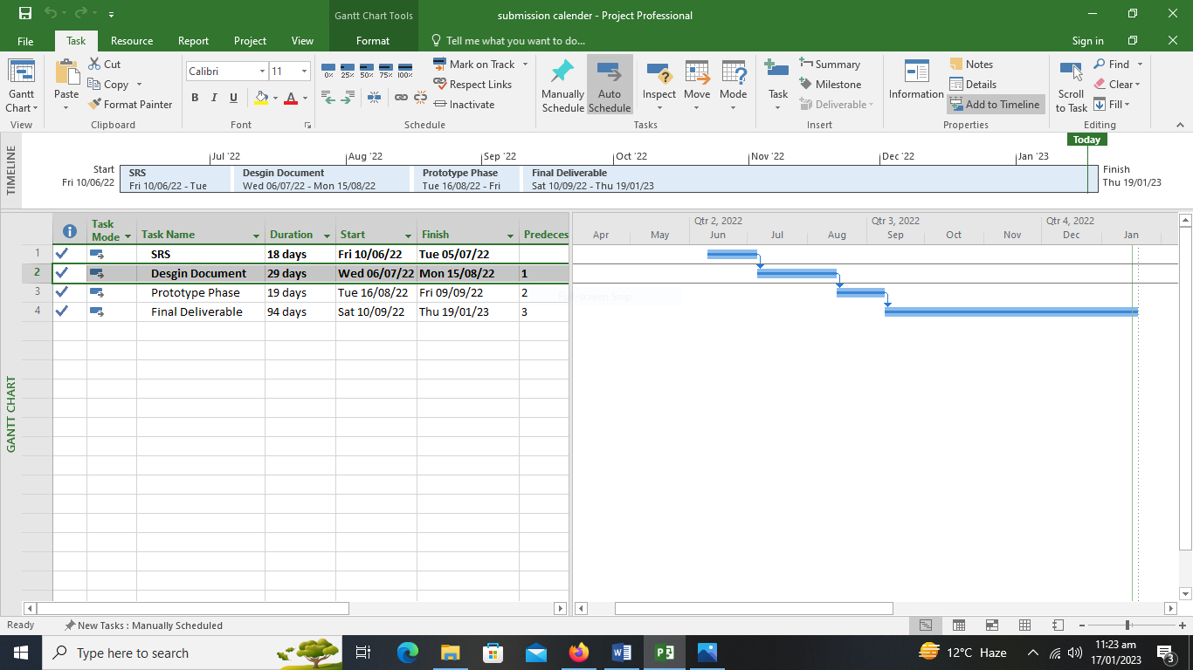

CHAPTER 2

Designing the Project

Introduction

Project Purpose
The main object of E-Drug Store Administration is to provide the medical stores and medical professionals the service to aid in their regular work through the software which will manage sale purchase, medicine details, the stock information and the profit loss of the month or year etc.

Software Features
- Saves the information about the sale purchase.
- Save the Medicine information, its price, uses and similar medicines for the same kind of disease etc. in Database.
- Can generate a receipt for every customer.
- Automatically delete the item from the stock after sale.
- Save the information about the stock.
- Can generate a profit loss table of a day, week, month or year.
- Can tell you the items which are low in stock and needed to purchase.
- User Friendly and Fast

Operating Environment
It is a window based application that will run on all window operating systems.

Scope
The scope of this project is to provide the medical store staff and medical professionals the service to aid in their regular work through the software which will manage the inventory which further includes sale purchase, profit loss reports and the stock information. Another main function that this software exhibit is that it will help the salesmen of store to see the item price, to check whether the following medicine is available or not what are the certain ingredients in that item or medicine. Moreover it will also provide two types of account Admin account and the user (Salesmen) Account. Both the Admin and the User have to login first to launch an instant of the software. The managing of stock and the inventory would be in the responsibility of the admin it he or she can only check the inventory make sale or purchase reports, can add the new users, modify the stock which further includes addition , updating the existing medicine records and removal of the decline medicines. In contrast to the user account which can only search for the medicine get its details sale the medicine and can print the receipt. Software have some restriction or u can say the authorize level for both account as them both are for different purposes, for example the user can’t add stock can’t make report or anything that is the work of admin user can’t perform.

Definitions, Acronyms and Abbreviations
Used Abbreviations and Acronyms:
- DS: Drug Store
- AD: Administrator
- FR: Functional Requirement
- US: Use Case
- ADDMED: Add Medicine
- UPDMED: Update Medicine Details
- DELMED: Delete a medicine Details
- ADDUSER: Add new User
- DELUSER: Delete a user
- INVEN: inventory
- SEMED: Searching medicine
- SELMED: Selling medicine

Architectural Representation (Architecture Diagram)
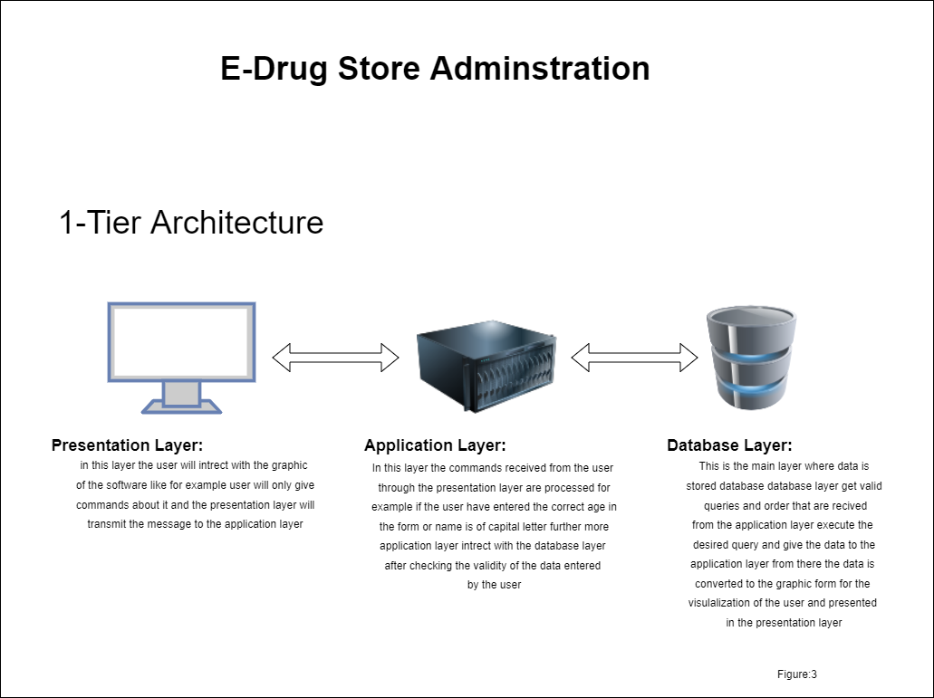

Dynamic Model: Sequence Diagrams
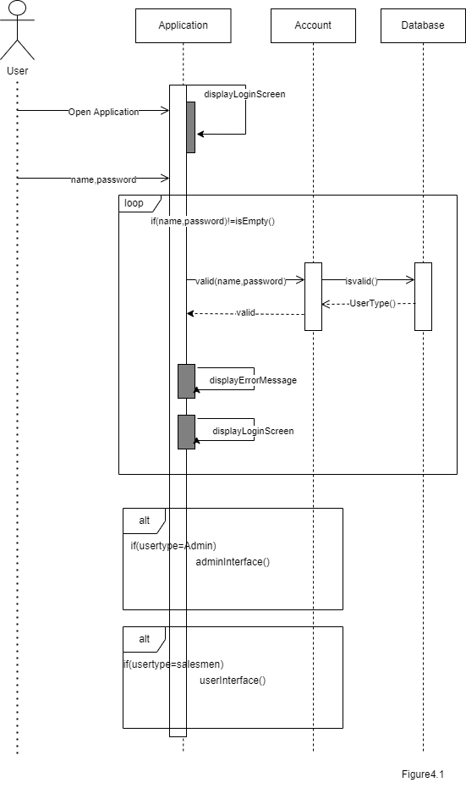
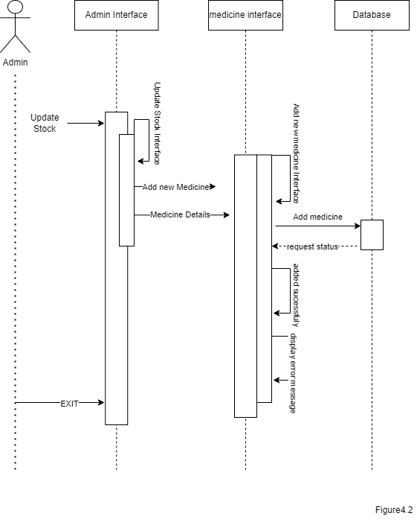

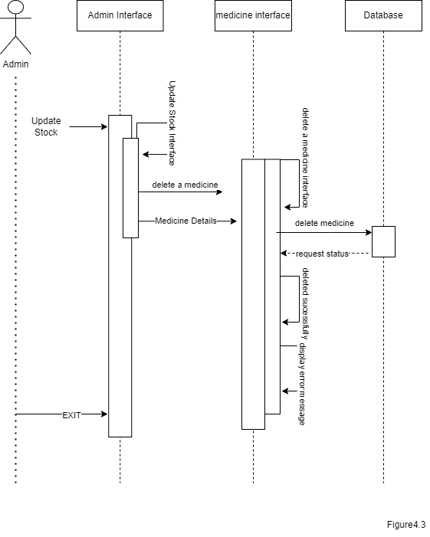
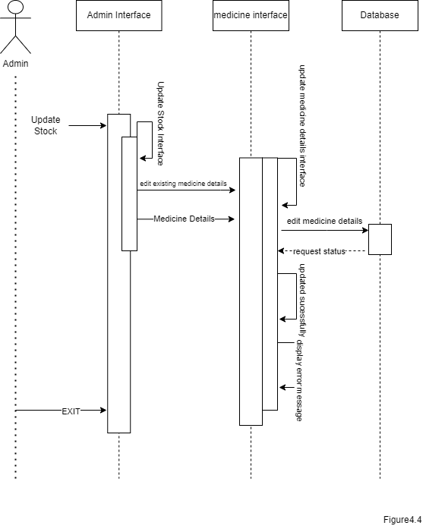

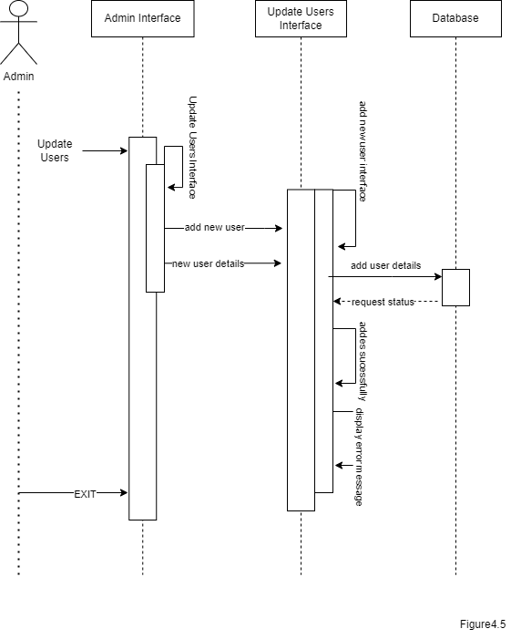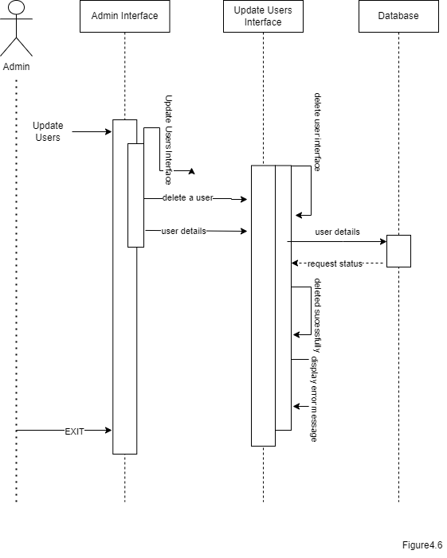

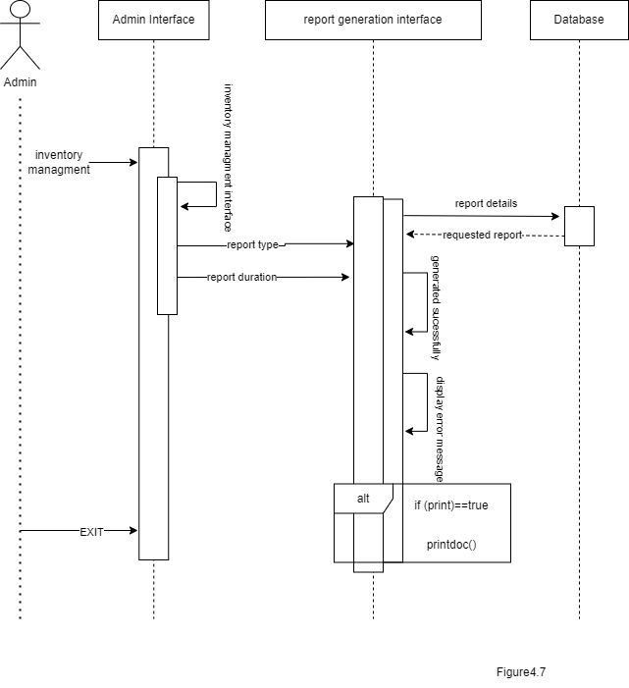
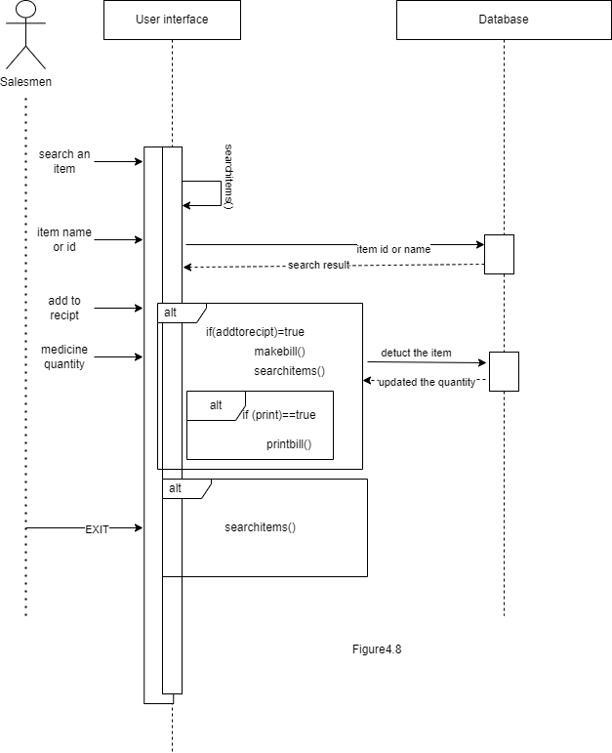

Object Model/Logical Model: Class Diagram

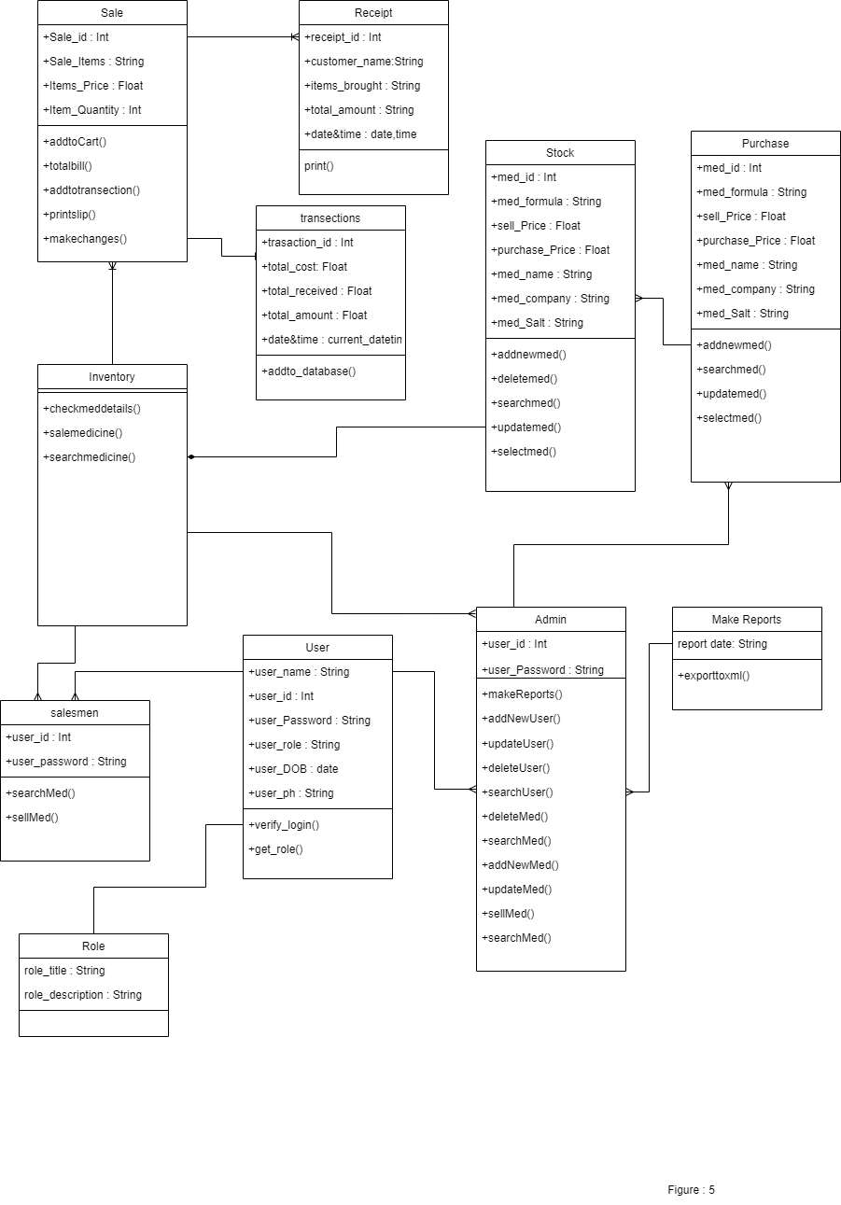

Database Model (Database Diagram)

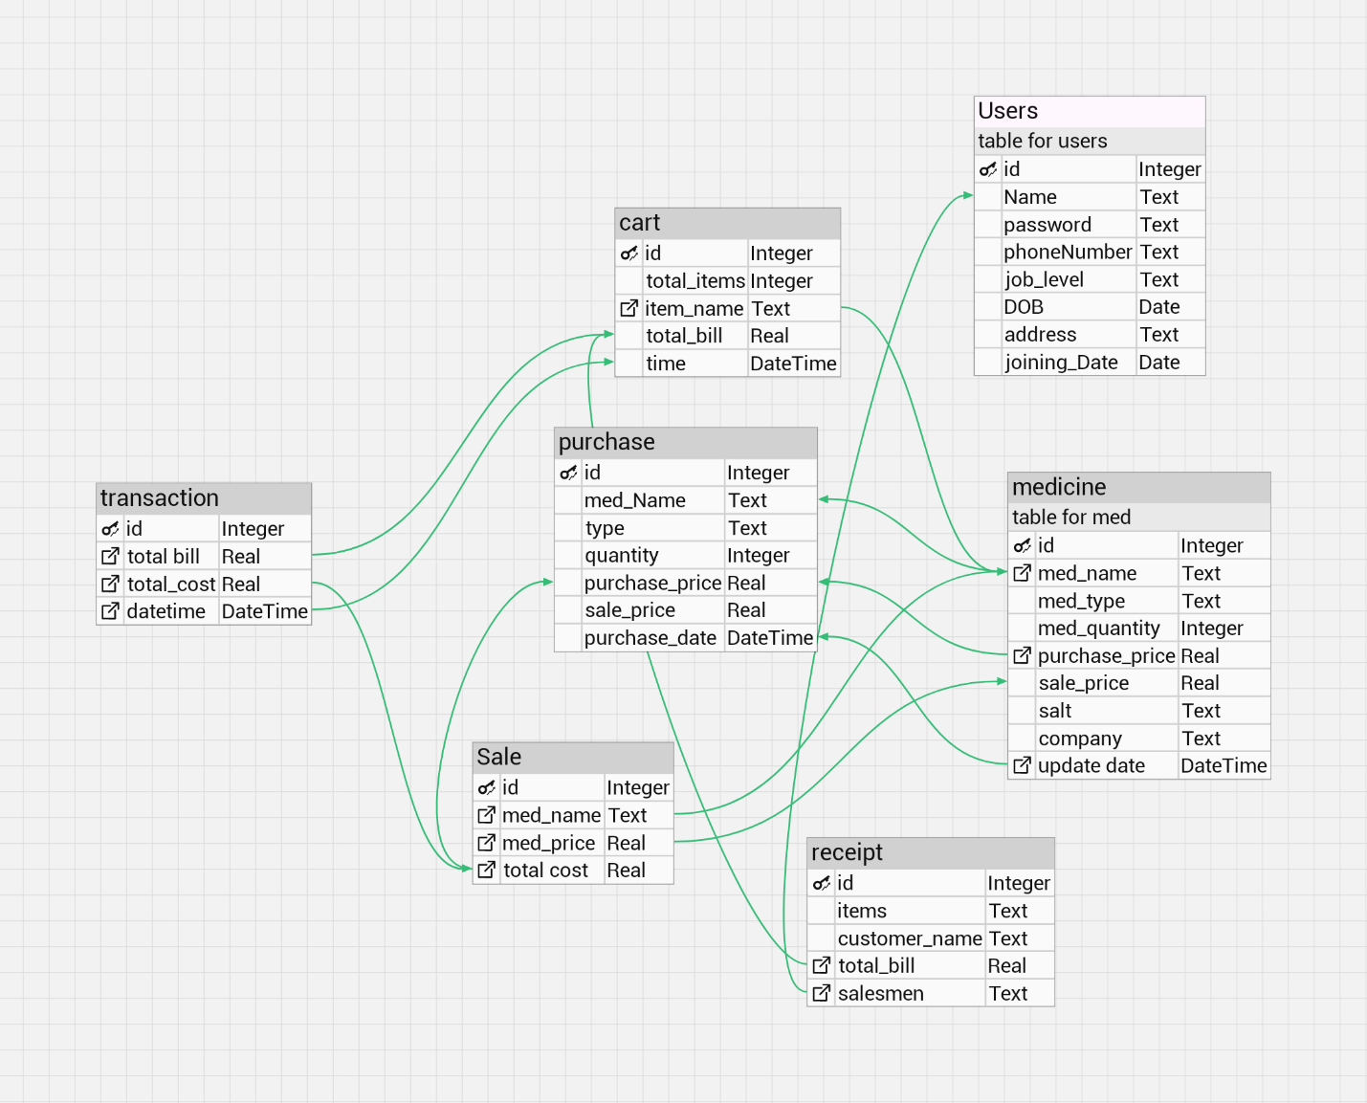

Graphical User Interfaces

Login Page
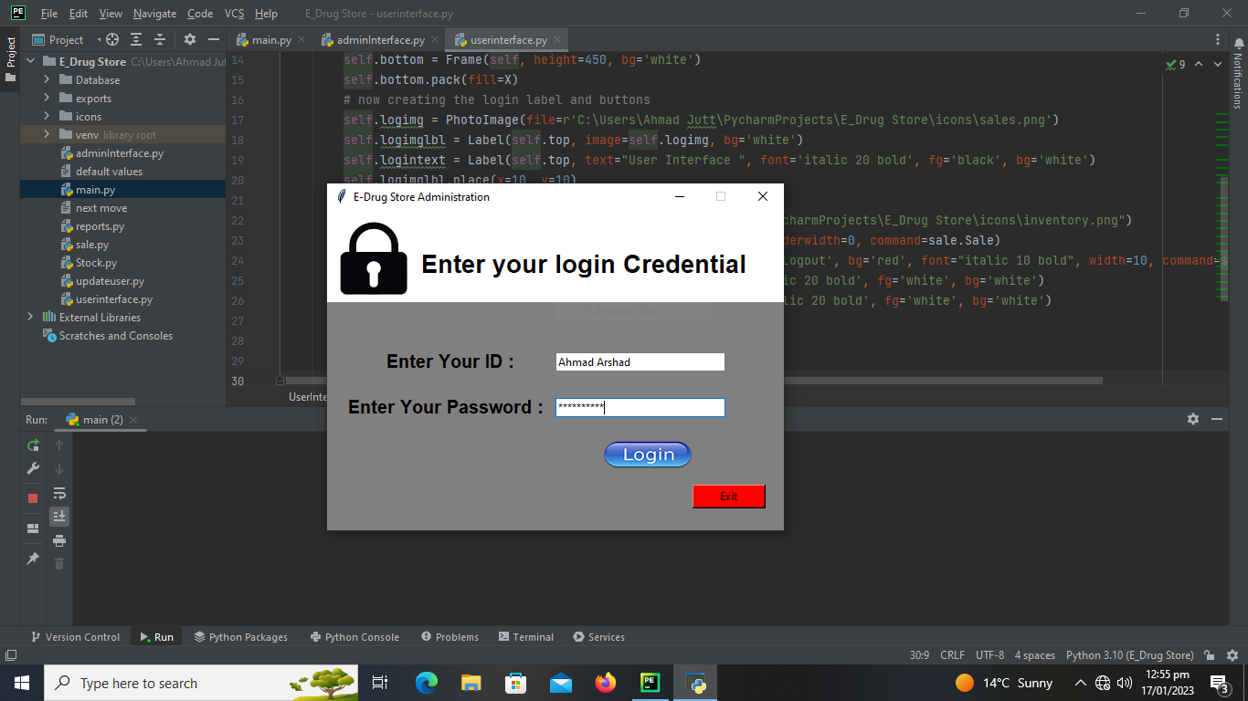

Admin Panel
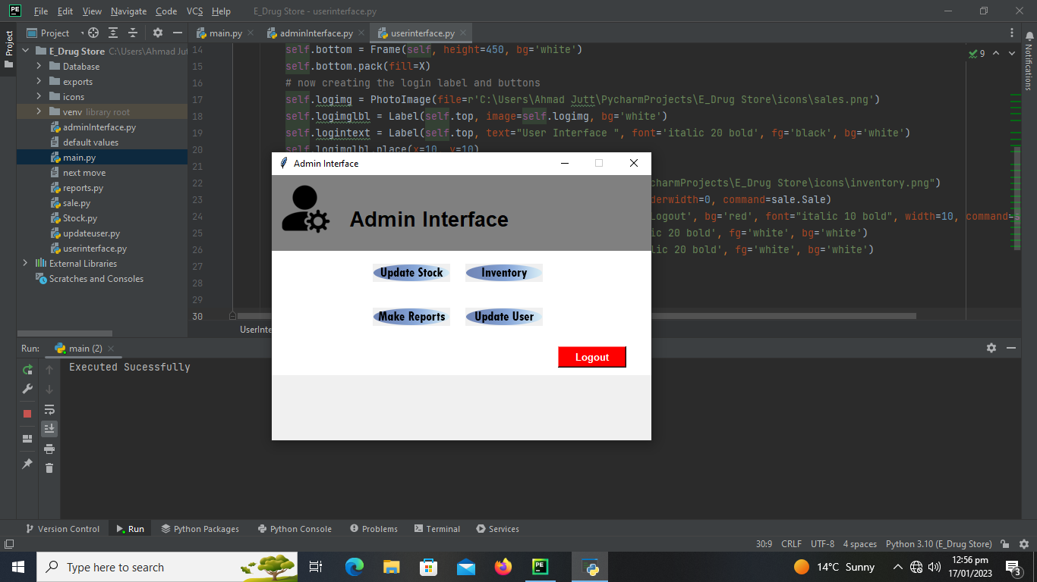

Manage User Interface
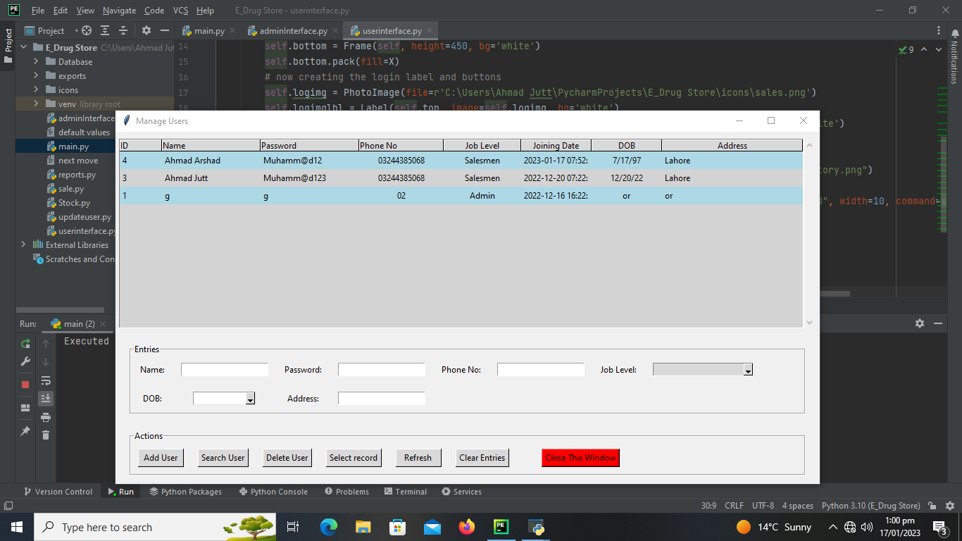

Report GUI
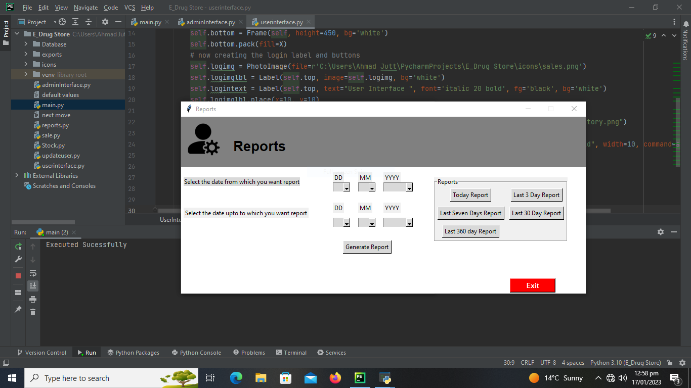
INVENTORY SALE GUI
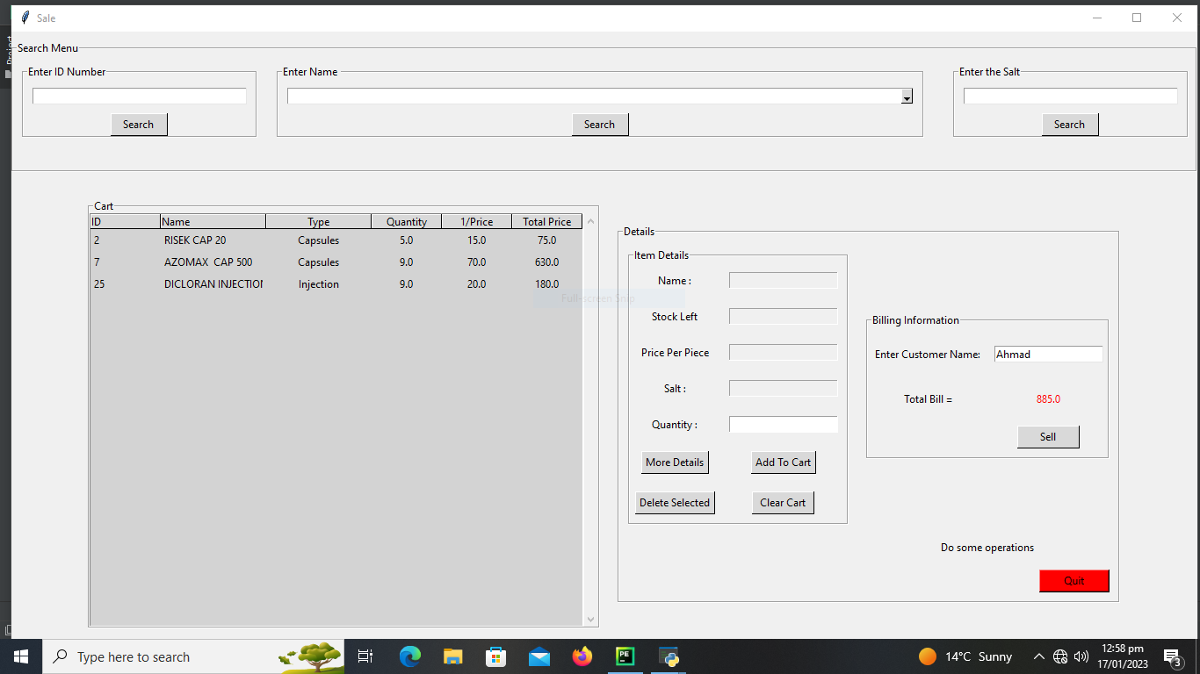

SALESMEN PANEL
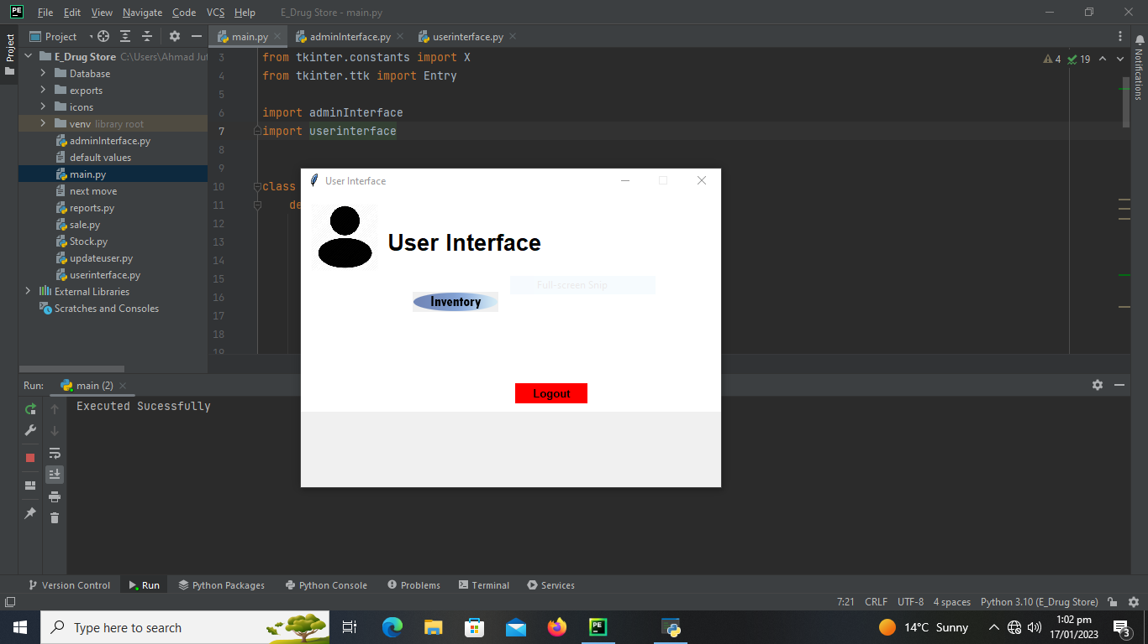
MANAGE STOCK INTERFACE
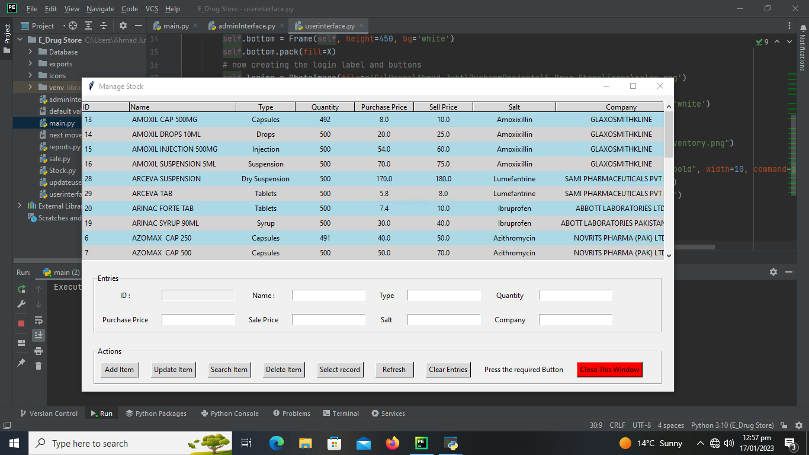

CHEPTER 3

DEVELOPMENT

REFERENCES

No. | Material | Link
1 | Tutorial | https://www.codewithharry.com/videos/python-tutorial-easy-for-beginners/
2 | Tutorial | https://www.w3schools.com/python/
3 | Tutorial | https://docs.python.org/3/tutorial/
4 | Notes | https://www.youtube.com/codewithharry
5 | Notes | https://www.pythontutorial.net/
6 | Handout | Cs504: Software engineering 1
7 | Handouts | Cs403: Database Management System
8 | Handouts | Cs615: Software Project Management

Author: Ahmad Arshad
Student ID: BC170202448
Email:bc170202448@vu.edu.pk
ahmadarshad12345@gmail.com

Appendix

Chapter 1 | Gathering and analyzing info
Chapter 2 | Designing the project
Chapter 3 | Development

